**PRACTICAL-5**

**AIM: To create a Network using Switch and Routers**

1. Why subnetting is required?

***ANS:* Subnetting** helps to reduce the network traffic and conceals network complexity. **Subnetting** is essential when a single network number has to be allocated over numerous segments of a local area network (LAN). **Subnets** were initially designed for solving the shortage of IP addresses over the Internet.

1. What do you mean by CIDR?

***ANS:*** Classless inter-domain routing (**CIDR**). It will help us to save ip otherwise assigning private ip to all is cost effective and difficult.

1. What information you get from subnet mask?

***ANS:*** Subnet mask provides information about how many number of bits are in or available for network parts

1. If the slash notation is /26. What information do you get from this?

***ANS:***It gives information that first 26 bits are network part rest are host ip.

1. You need to configure a server that is on the subnet 192.168.19.24/29. the router has the first available host address. What IP you can assign to the server? (Mention the subnet mask as well)

***ANS:***192.168.19.26/24 is the ip you can assign to server also between(192.169.19.26 to 192.168.19.30) any server or device will get ip in this range if subnet is 192.168.19.24/29 because 192.168.19.24 is network ip and 192.168.19.31 is broadcast ip for this subnet and first one is required in router so left are 26 to 30 (5 ips)

Subnet mask:255.255.255.248

1. If you configure a router interface with the IP address 192.168.10.62 255.255.255.192 and received an error. What can be the possible reason for that?

***ANS:***

* Let us ignore first three octet which is perfect because 255.255.255 is the valid subnet which shows that 3 octet is there in network let’s talk about 4th one 192 it means 11000010 is in network means 255.255.255.11000010 is network part
* You cannot assign 00 in between because it is the bits that is positioning continuously in giving network there is no such network where you can have first part in network then host then network (as 0 represents host bits and their possibilities and 1 for network so this is not correct)
* Instead we can give (255.255.255).11000000 means 255.255.255.190 as subnet for given ip (classless domain specifically not in classfull addressing.)

1. What is IP subnet-zero?

***ANS: IP*** subnet 0 means network ip

Example 192.168.1.2 has classfull subnet 255.255.255.0 means this is the network subnet mask and 192.168.1.0 this 0 is showing that its is a network ip means 0 in subnet mask is related to ip of specific network.

DESIGN A NETWORK USING SWITCH AND ROUTER

Steps: 1 start cisco packet

Choosing Devices and Connections

We will begin building our network topology by selecting devices and the media in

Which to connect them. Several types of devices and network connections can be

Used. For this lab, we will keep it simple by using End Devices, Switches, Hubs, and connections

step 2 Choose “End Devices”

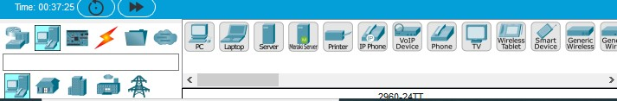

Select and place it into workspace.

Step 3 Click at the workspace to see the PC. Repeat the above process to place all 8

PCs.



Step 4: 4: Add switches also by clicking on “Network Devices” and choose Switch.

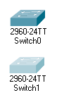

Step5: Add Routers by clicking on “Network Devices” and choose Router.

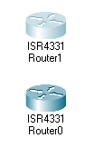

Step 6: Connect PC-0 & PC 1 with Switch 0, Switch0 with Router0 And pc-2 & pc3 with switch 1 , switch 1 with router 0.

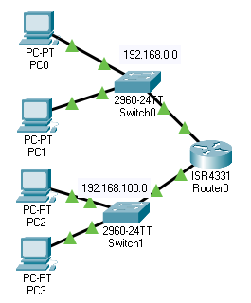

For pc0:

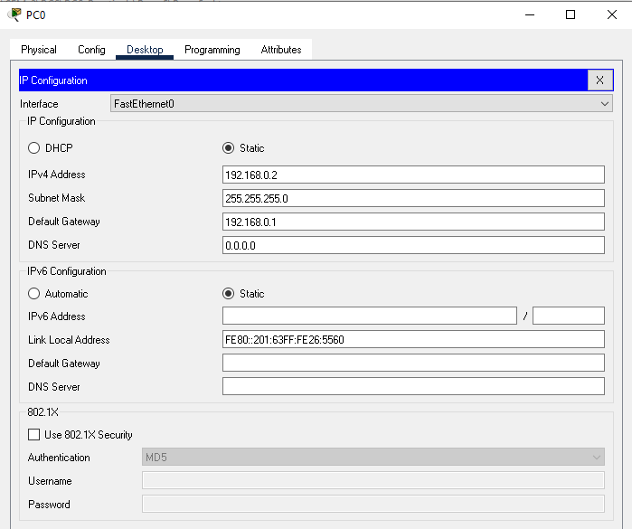

Pc 1:

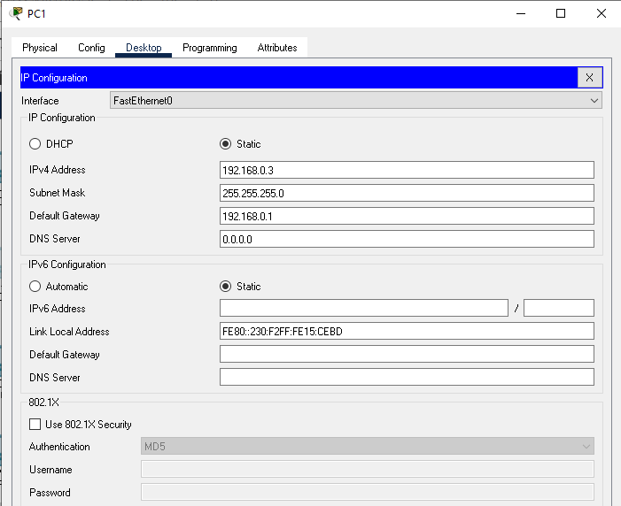

Pc 2:

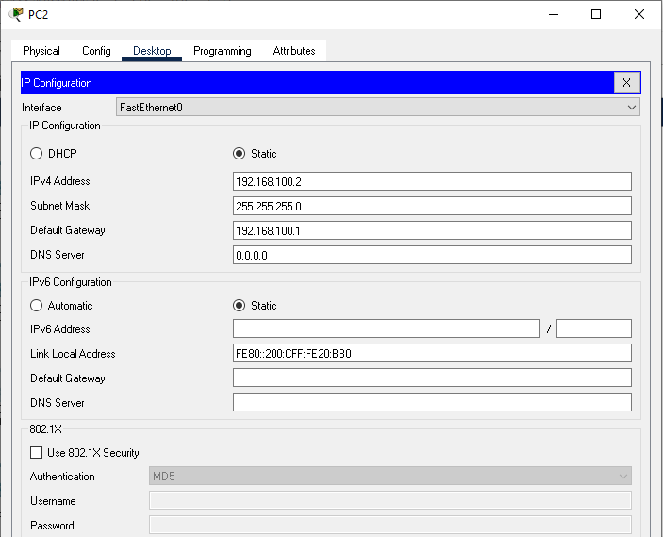

Pc 3:

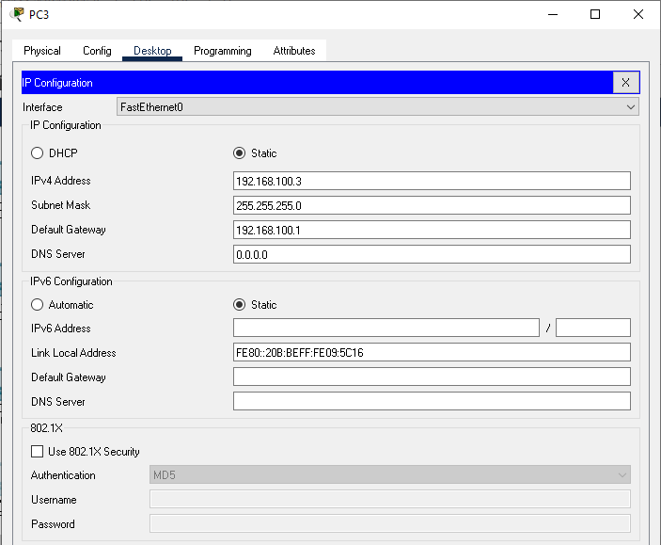

For router 0 and network 1

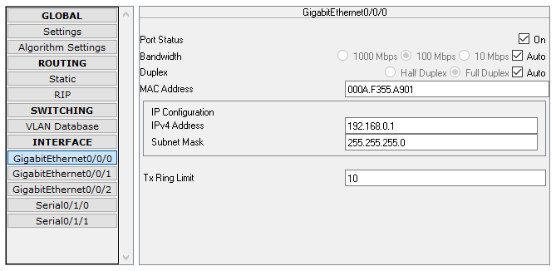

For router 0: network 2: downside GigabitEthernet0/0/1:

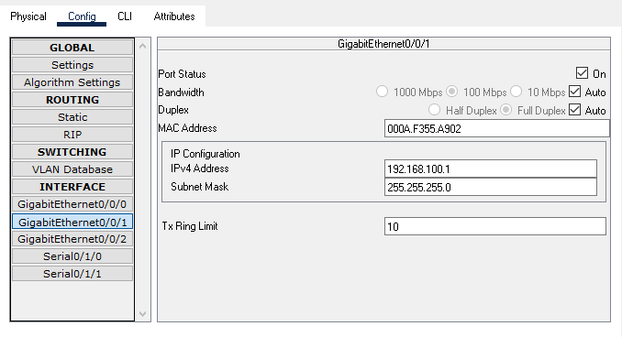

Step 6: Now make similar network on right side one router two switch and respective devices:

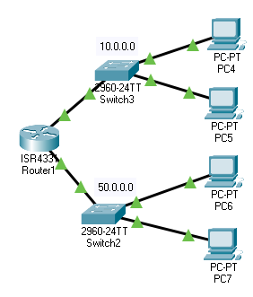

For pc4:

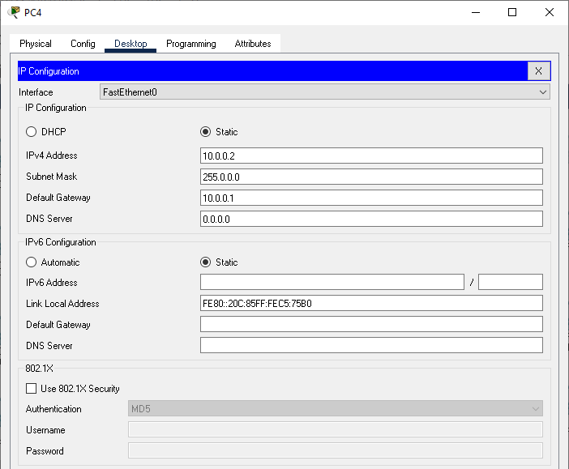

For pc5:

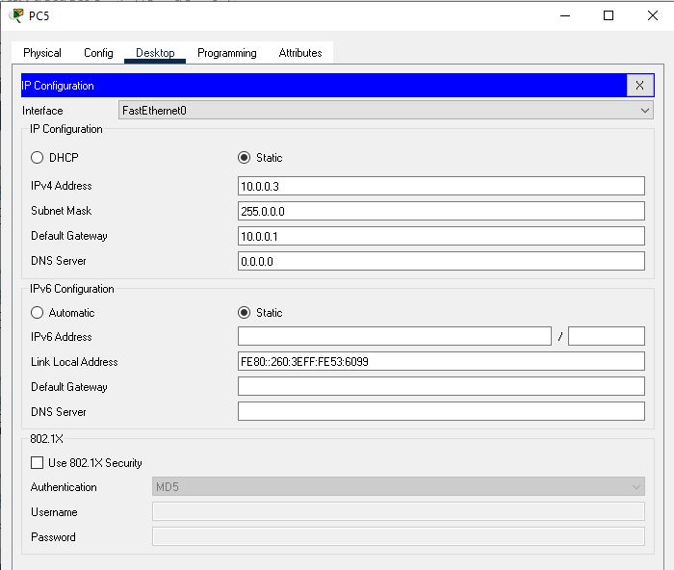

For pc6:

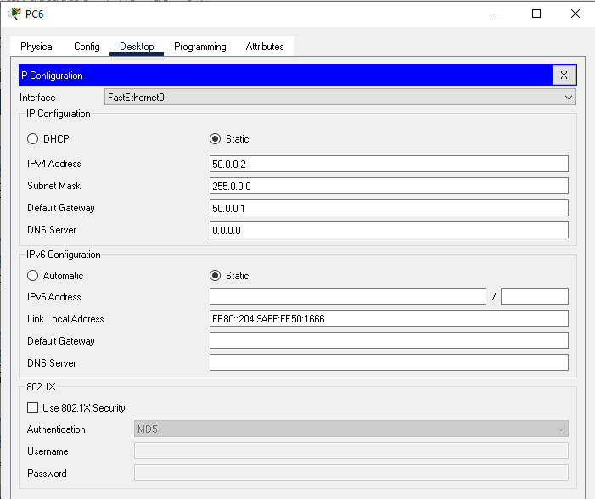

For pc7:

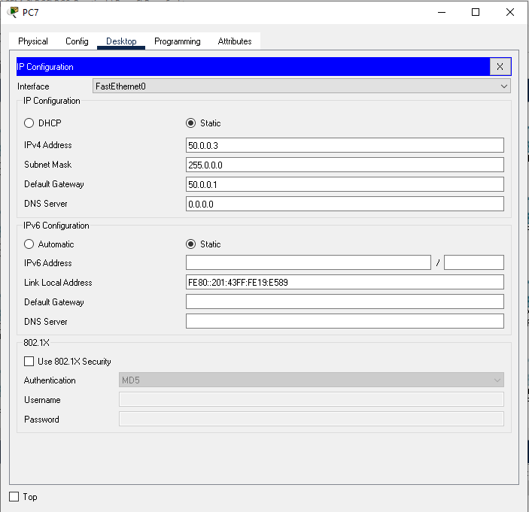

For router 1:network 1:

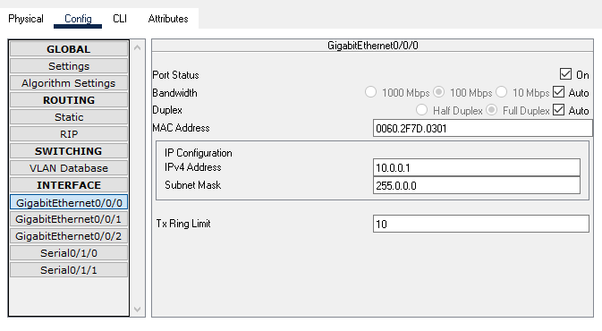

For router 1: network 2:

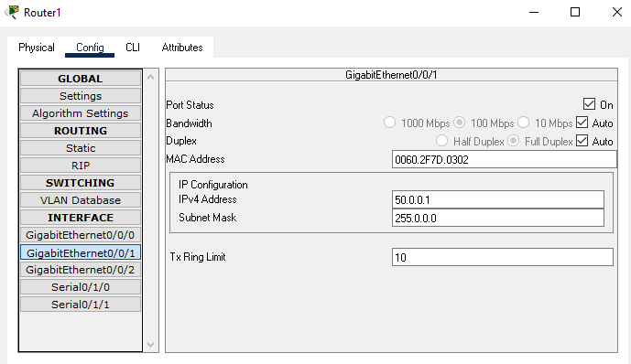

Step 7:Now it is time to connect two routers it will require serial port that needs to be added into network

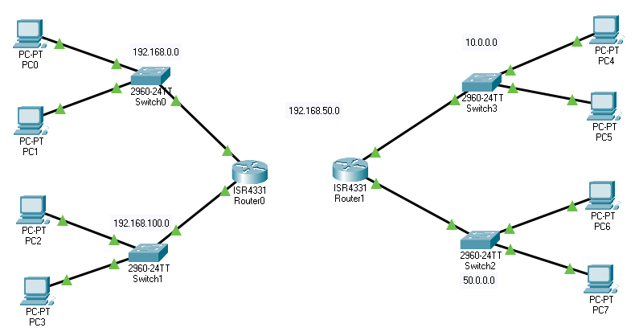

Step 8:Now to add serial port click on router go to router

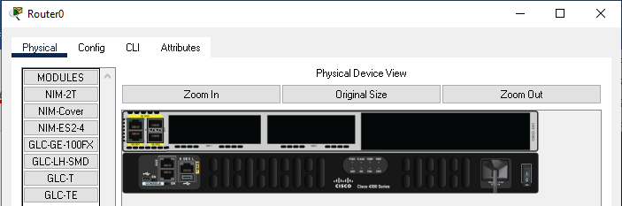

Select NM-Cover and drag one serial port by like this power off the module:

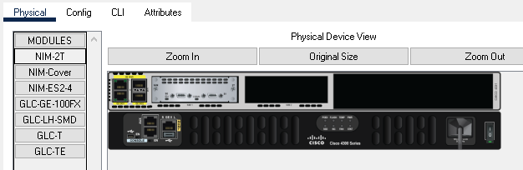

Then it will open a new window for that will provide serial option:

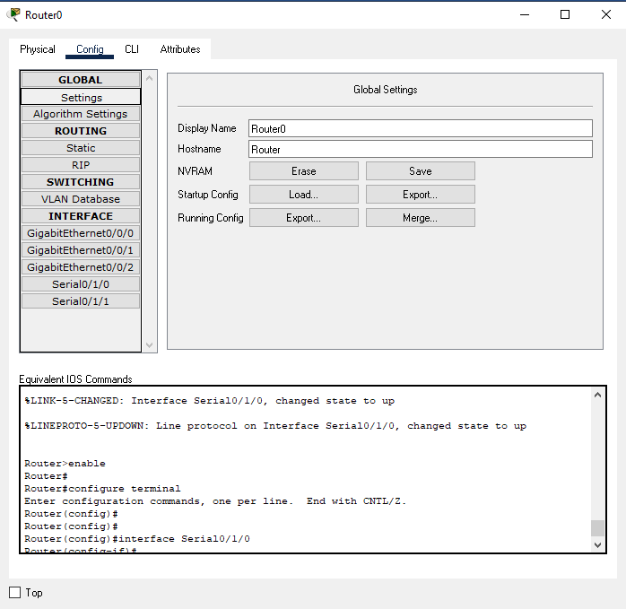

Serial port 0/1/0 configuration is applied for router0

Assign IP address to serial 0/1/0 by clicking on Router0, then click on

“Config”, click on “Serial o/1/0” and configure IP address, set clock and then turn the port “On”.

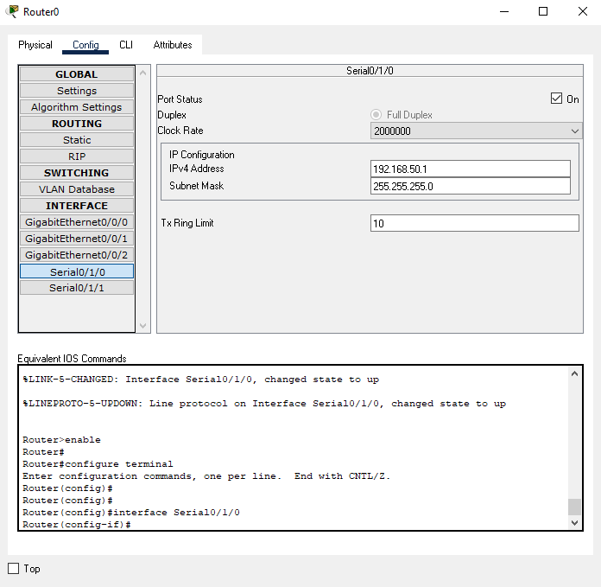

Now same for router 4:

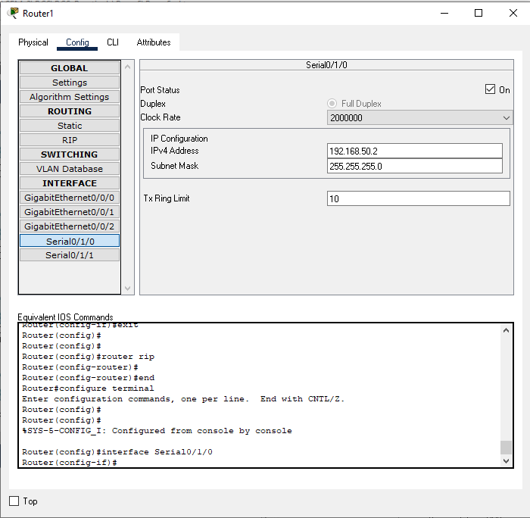

And use serial port



Step 9:Try to pass message from PC0 to PC1. It would still fail .because connection is not completed

Step 10:To connect it on serial0/1/0 with router0 and router1

Use Static routing configure Router0 and Router4 by adding number of networks that they know.

It will be done by clicking on Router0, then click on “Config”, click on “static” and finally add networks. Add the route in router 1 also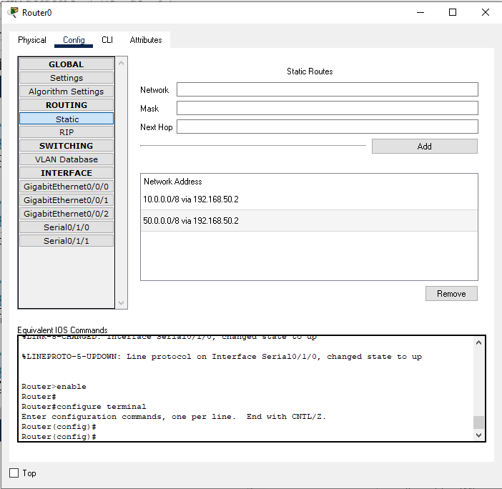

FOR ROUTER1

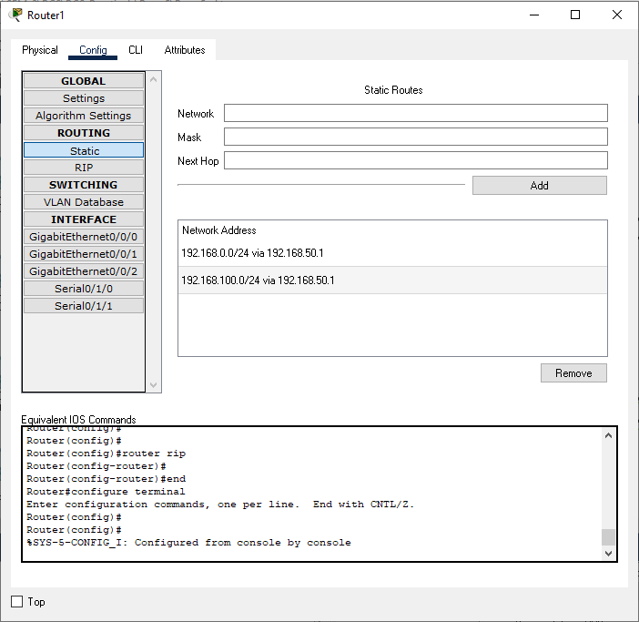

Step 11:Try to send packet from PC0 to PC1. Initially it will fail. Then wait for 10 seconds and then the packet will be delivered successfully.

